**Muhammad Umar Ahmadzai**

**09/15/2017**

**Extra Assignment: Stamp Machine**

**Problem Statement:**

This program is going ask the user to chose from rock, paper and scissors. Computer will randomly chose one of them as well, and play a rock paper scissors game. For instance, if user chooses rock, and computer chooses scissors. Computer will lose.

**Input/output Description:**

**Outputting game’s format:**

cout << "Welcome to the rock, paper and scissors game." << endl << endl;

cout << " Please choose one of the following: " << endl << endl;

cout << "Press 1 for rock." << endl;

cout <<"Press 2 paper." << endl;

cout << "Press 3 scissors." << endl << endl;

**User will input the choice:**

cin >> userchoice;

**Used it else statements to define condition, if a user wins, losses or if it’s a tie:**

if ((userchoice==1 && computerchoice==3 ) || (userchoice==2 && computerchoice==1) || (userchoice==3 && computerchoice==2))

{

cout<< endl << "You win!" << endl;

}

else if ((userchoice==2 && computerchoice==3 || userchoice ==3 && computerchoice==1 || userchoice==1 && computerchoice==2))

{

cout << endl << "You lost!" << endl;

}

else if (computerchoice==userchoice)

cout << endl << "It's a tie!" << endl;

cout <<endl << "Computer choice was " << computerchoice << "." << endl;

}

**Algorithm Development:**

Basically, we are inputting user choice and program is randomly going to generate its choice. Program will compare them and find out the results. Conditions are defined for the program, so it is going to apply it accordingly. Used if else statements for conditions to be applied.

**Program Listing:**

#include <iostream>

using namespace std;

int userchoice, computerchoice;

int main()

{

cout << "Welcome to the rock, paper and scissors game." << endl << endl;

cout << " Please choose one of the following: " << endl << endl;

cout << "Press 1 for rock." << endl;

cout <<"Press 2 paper." << endl;

cout << "Press 3 scissors." << endl << endl;

cin >> userchoice;

srand((unsigned)time(NULL));

computerchoice = (rand() % 3) + 1;

if ((userchoice==1 && computerchoice==3 ) || (userchoice==2 && computerchoice==1) || (userchoice==3 && computerchoice==2))

{

cout<< endl << "You win!" << endl;

}

else if ((userchoice==2 && computerchoice==3 || userchoice ==3 && computerchoice==1 || userchoice==1 && computerchoice==2))

{

cout << endl << "You lost!" << endl;

}

else if (computerchoice==userchoice)

cout << endl << "It's a tie!" << endl;

cout <<endl << "Computer choice was " << computerchoice << "." << endl;

}

**Observation and Error Handling and general comments:**

Did not faced any errors.

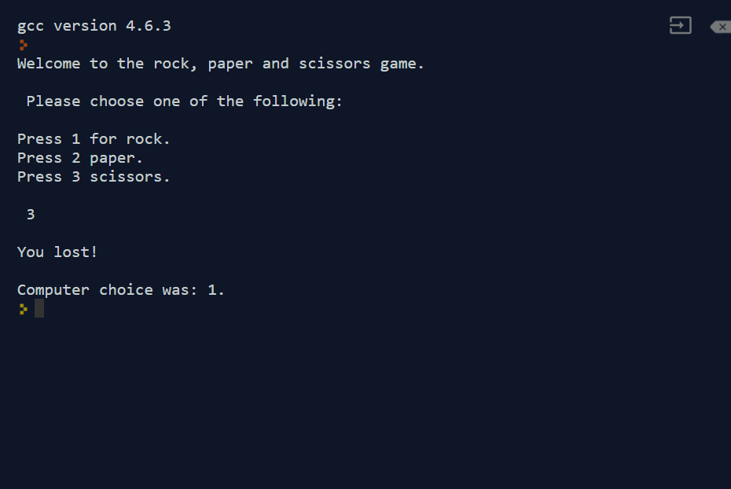

**Conclusion:**

In conclusion, it will play a game with user. Will compare user’s inputs and its own randomly generated choice, and will output the result.